Name ___________________________________ Date _______________________

Mathematics Grade 1 Unit 6 Study Guide
*Post Assessment on ____________________.
Understanding Shapes and Fractions
G.1
- Compare the 2 shapes below using defining attributes.

a.) How are these shapes alike?

b.) How are these shapes different?

G.1
2.) Compare the 2 shapes below using defining attributes.

a.) How are these shapes alike?

b.) How are these shapes different?

G.1
3.) Solve.
a.)Circle the square.

b.) How do you know the shape you circled is a square?

_________________________________________________________________________________________________________________________________________________________________________________________________________

G.1
4.) Think about the defining attributes of the shape below.

Write True or False next to each statement.

____________a.) Black is a defining attribute of this rectangle.
____________b.) This rectangle has 4 vertices.
____________c.) 4 sides is a non-defining attribute of this rectangle.
____________d.) The size of this rectangle is a defining attribute.

G.2
5.) Create a robot using at least one of each shape: rectangle, circle, square, triangle, trapezoid, and half circle.

G.2
6.) Which 3-dimensional shapes would be needed to make a snow cone?
Circle 2 shapes.

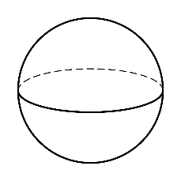
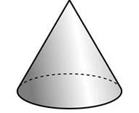

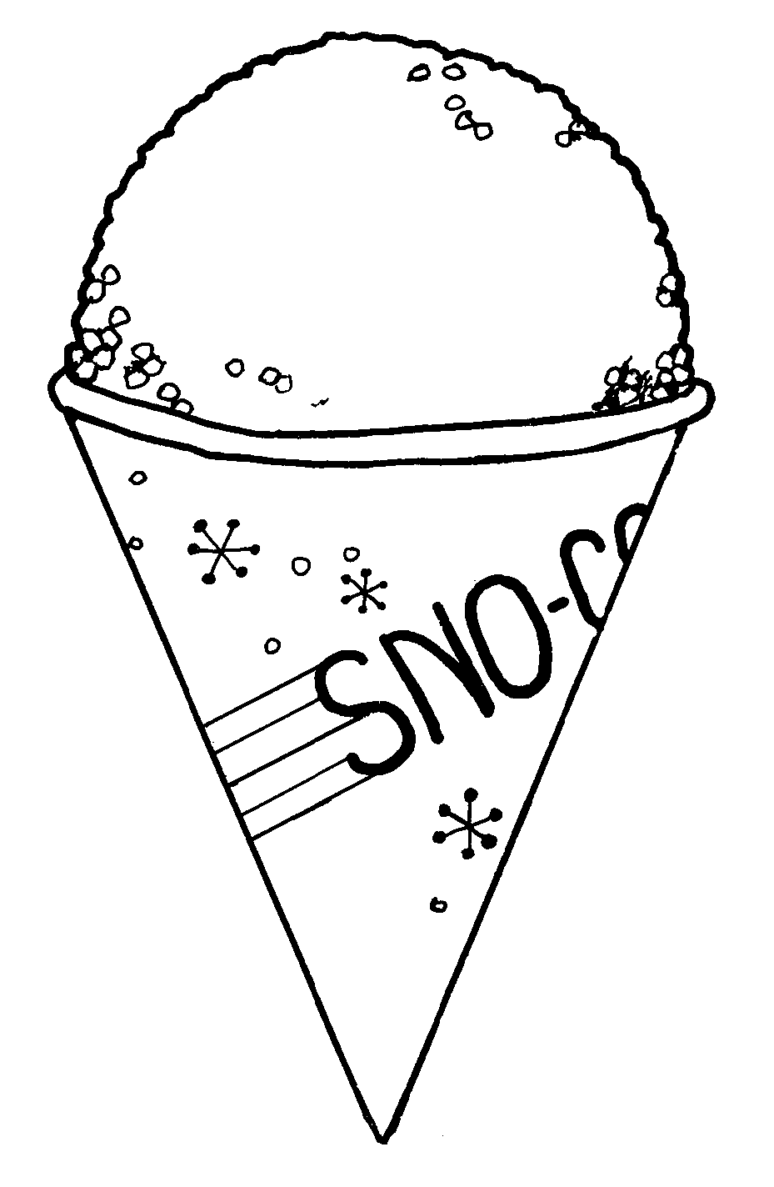

G.2
7.) Which shape can be composed from these 2-dimensional faces?

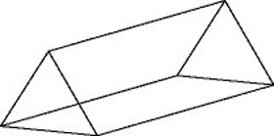

- ) C.)

- ) D.)

G.3
8.) Partition the shapes below.

a.) Divide the shapes into fourths.

b.) Divide the shapes into halves.

G.3
9.) Which shape is shaded to represent a fourth?

a.) b.) c.) d.)

G.3
10.) Which shape is shaded to represent a whole?

a.) b.) c.) d.)

G.3
11.) Solve.
a.) Beth ate a fourth of her chocolate bar. Shade a fourth of her chocolate bar. Ben ate half of his chocolate bar. Shade a half of his chocolate bar.
Ben’s chocolate bar
Beth’s chocolate bar

b.) Who ate more chocolate? Explain your answer.
____________________________________________________________________
_____________________________________________________________________
_____________________________________________________________________

MD.4
12.) Tyler has the following shapes on his desk. How many of each shape does he have? Complete the tally chart below.

Shape | Tally Marks | Total

MD.4
13.) How many shapes does Tyler have on his desk?

- Tyler has 16 shapes on his desk.
- Tyler has 17 shapes on his desk.
- Tyler has 26 shapes on his desk.
- Tyler has 20 shapes on his desk.

MD.4
14.) Complete the statement below.

There are ________________ less cylinders than cones.

